

Capstone Project - Strut

Group 6

Assignment 1

Assigned Roles Section A

Moegamat Tashreeq Waggie

Section B – Profiles and Scenarios

Jamie Lee Van Der Berg

Section C

Jamie Lee Van Der Berg

Section D

Khuliso Sikhwivhilu

Areeb Royeppen

Dean Ockhuizen

Section E

Dahraan Abrahams

Moegamat Ismaeel Ed'rees Jefferies

Section F

Areeb Royeppen
Project Evaluation One

Section A

Interview (one-on-one)

This is one of the most common gathering techniques which allows us to understand what the stakeholders like about the current method of finding venues as opposed to the one which is to be created. It allows us to understand the concerns that the stakeholders might have regarding the new mobile application. Interviews gathering techniques allow us to know which improvements to make to the method of find venues when creating the mobile application and what features stakeholders would find very useful in the mobile system that are not in the current system.

Link to interview questions –

https://drive.google.com/file/d/1tu0bCIQ1N_YOzrllDMkQLyaX-ga6SrnO/view?usp=sharing

Link to interview recordings –

https://drive.google.com/drive/folders/1eW8nDxPctUdkOB6B4vT_UWalQ7sXmkhw?usp=shari ng

Conducting a survey

Conducting survey can produce qualitative and quantitative data. An online survey provides the opportunity to reach out to a larger and diverse group. This also allows us to clear up the software requirements for the developers. As of the tying of this there is over 30 responses that filled out the survey.

Link to full survey (If you want to view the full questionnaire press the edit button top right) –

https://docs.google.com/forms/d/1-

G3DSJQLzixiVr4PfaeSnejVAEzl8yo1ZOnVhv5xhCI/edit?usp=sharing

Link to live online survey (Depending on what you respond for a specific question it will take you to a specific section)-

https://docs.google.com/forms/d/e/1FAIpQLSeGME2NEEZRfj6Bpvz1stVaSsBUlvXz2iWm3ISJx_V ATOJE7w/viewform?usp=sf_link

Researching similar mobile applications

This is used as a starting point of the project where we look at similar products that is already being used. This gives us a basis and an example of how the mobile application should work and information about the work that that needs to be done for our mobile application for it to meet its objective. Reviews allow for use to think of what feature the user would like and

allows us to try and incorporate those features to improve functionality for the users.

Researching similar systems

Apps | Description
Google Maps | Web mapping service developed by Google in 2005
Apple Maps | Web mapping service developed by Apple Inc. in 2012
Citymapper | Public transit and mapping service developed by Citymapper Limited in
Citymapper | 2011
 | Origins date to 1967 with the founding of Cartographic Services, a
MapQuest | division of R.R. Donnelley & Sons in Chicago, Illinois, which moved to
 | Lancaster, Pennsylvania, in 1969

Section B

Profile 1

Name: Willem Steenkamp


Age: 20 years’ old

Gender: Male

Race: White

First Language: English

Studying LLB at UWC (First Year)

Only child

Uses Android device

About Willem:

- Forms part of many campus societies

- Has a long list of modules

- Drives to and from campus

Motivations:

- Helping the less fortunate

- Keeping in shape

- Sense of accomplishment

Frustrations:

- Being swamped with work

- Inability to remember song lyrics

- Being lost

Scenario 1

As a first-year student, Willem struggles to navigate through the large UWC campus. He often forgets which paths to take to get him from one class to another. With the large number of lectures, he has in a week, including the society workshops he attends, he finds it difficult to make it to classes or extra murals on time. For Willem, being lost is a massive frustration and

inconvenience. As such, he would be less anxious if there were a way for him to easily find venues or buildings without the burden of remembering everything.

Profile 2


Name: Thembile Mafu

Age: 42 years’ old

Gender: Male

Race: Black

First Language: isiXhosa

Agricultural Engineer

Has a wife and 2 kids

Uses Android device

About Thembile:

- Constantly travelling around

- Has meetings daily

- Horrible sense of direction

Motivations:

- His family

- BMW M5

Frustrations:

- Traffic

- Loud noises

Scenario 2

As a visitor of the University of the Western Cape, Thembile finds himself facing the daunting task of having to park at the Life Science building and find his way to the Community Health Sciences building where he has to attend a meeting with the university rector and the dean of the science faculty. In addition, he happens to only have five minutes to find the meeting venue. Thembile often finds himself in this predicament when visiting UWC or any other university. Thembile

would love to be able to easily navigate the university campus and reduce unnecessary stress before important meetings.

Section C

Hierarchical Task Analysis for Student (Scenario 1)

- To find venue/building

- Log in

1.1. Enter student number

1.2. Enter Password

- Get directions

2.1. Enter current location

2.2. Enter destination venue/building

- View Timetable

3.1. Choose Specific Period

3.2. Enter current location

- Venue Booking

4.1. Query available venues

4.2. Choose venue

4.3. Enter time of use

Plan 0: If user is a student; you can do 1, 2, 3, 4

Plan 1: If user is student; you can do 1.1, 1.2

Plan 2: If user is student; you can do 2.1, 2.2

Plan 3: If user is student; you can do 3.1, 3.2

Plan 4: If user is student; you can do 4.1, 4.2, 4.3

Hierarchical Task Analysis for Visitor (Scenario 2)

- To find venue/building

- Log in

1.1. Enter student number

1.2. Enter Password

- Get directions

2.1. Enter current location

2.2. Enter destination venue/building

Plan 2: If user is a visitor; you can do 2.1, 2.2
Hierarchical Task Analysis Diagram
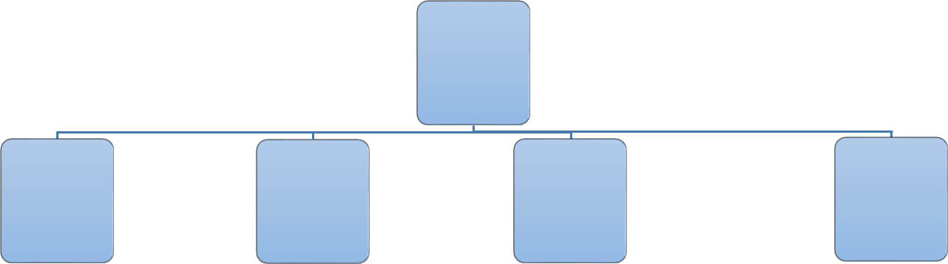

To find a
venue/b
uilding
Plan 0: 1, 2, 3, 4
0

 |  |  |  |  |  |  |  | Get |  |  |  |  |  |  | View
 |  | Log in |  |  |  |  |  | direction |  |  |  |  |  |  | Timetabl |  |  |  |  |  |  |  | Venue
 |  |  |  |  |  |  |  | s |  |  |  |  |  |  |  | e |  |  |  |  |  |  | Booking
 |  |  | 1 |  |  |  |  |  |  | 2 |  |  |  |  |  | 3 |  |  |  |  |  |  | 4
Enter |  |  | Enter |  |  | Enter |  |  |  | Enter |  |  | Choose |  |  |  | Enter |  |  | Query |  |  | Choose |  | Set time
student |  |  | passwor |  |  | current |  |  |  | destinati |  |  | period |  |  |  | Current |  |  | available |  |  | venue |  | of use
number |  |  | d |  |  | location |  |  |  | on |  |  |  |  |  |  | Location |  |  | venues
1.1 |  |  | 1.2 |  |  | 2.1 |  |  |  | 2.2 |  |  | 3.1 |  |  | 3.2 |  |  |  | 4.1 |  |  | 4.2 |  | 4.3
 |  | Plan 1: 1.1, 1.2 |  |  |  |  |  | Plan 2: 2.1, 2.2 |  |  |  |  |  |  | Plan 3: 3.1, 3.2 |  |  |  |  |  |  |  | Plan 4: 4.1, 4.2, 4.3

Section D

Process Model

During Software Engineering we have learned a few different process models and the one our group settle on was the Agile (Scrum) process model. The reason we chose this methodology was because it is based on teamwork, it allows for close collaboration with customers and stakeholders, flexibility and ability to adapt to change in requirements and better manage all tasks. It allows use to iteratively gather requirements throughout the development process. The building blocks of Agile are planning, analysis, design, development and testing. The idea is to produce documentation with information to move forward when it makes sense.

General Principles

- Abstraction

The user will only be shown digestible information rather than technical details which is hard to understand.

- Localization

The app will only display to the user information which is relevant to their current location query.

- Hiding

The user will not be shown the background workings of the application, they will only be presented with the results of the background activities which will help navigate them towards their destination.

- Completeness

The application will fulfil all the user requirements, which in this case is providing sufficient information to users so that they may reach their requested destination.

Goals

- Understandability

The application will be easy to use, and users will be able to quickly identify how to use the application. When users use the application for the first time, we plan to construct and implement a walkthrough which will take a user through steps of how to use the application.
- Reliability

The application will be reliable to use without losing any of its functionality or crashing at random times leaving users unable to use it.

- Security

Users who are not visitors will always need to be logged in with their own login details in order to utilize the application so that other users may not have access to their details and information. The data we store in the database will not be available to unauthorized persons, this is so that user’s data that we store remains safe and unavailable to unauthorized and/or third parties with malicious intent.

Umbrella Activities

- Software project tracking and control

Tracking the progression of the project is key given the short amount of time at hand to complete tedious and complex tasks. Our team is using Agile Scrum Methodology which best suits for the short time and uncertain timetables of our team members. Having daily sprints of various time frames will allow the team to keep track of accomplished tasks to date.

- Software Quality Assurance

Making sure the software meets the functional requirements of the project. Given that the system is to work on a daily basis, careful consideration will be put into building the application to cope with daily operation. The application will also be built with familiarity to presently operating navigating systems to ensure that the system is usable.

- Technical Reviews

Examining the suitability of the application for daily navigational use and identifying any discrepancies from specifications and standards. Reviews gathered from testing. Testers will include Developer, Students and Visitors.

- Software Configuration Management

Software Configuration will be occurring every 2 months to update the paths recorded after the use of the app for those 2 months by students and visitors that will be using the application. Updates to the paths will include new shortest paths to and from buildings, and possible new spots that students and visitors go to frequently.
- Reusability Management

Some of the functionality of the software was reused and was made possible via Google’s Map API’s, since google maps is able to locate paths and paths to buildings.

Use Case Diagram
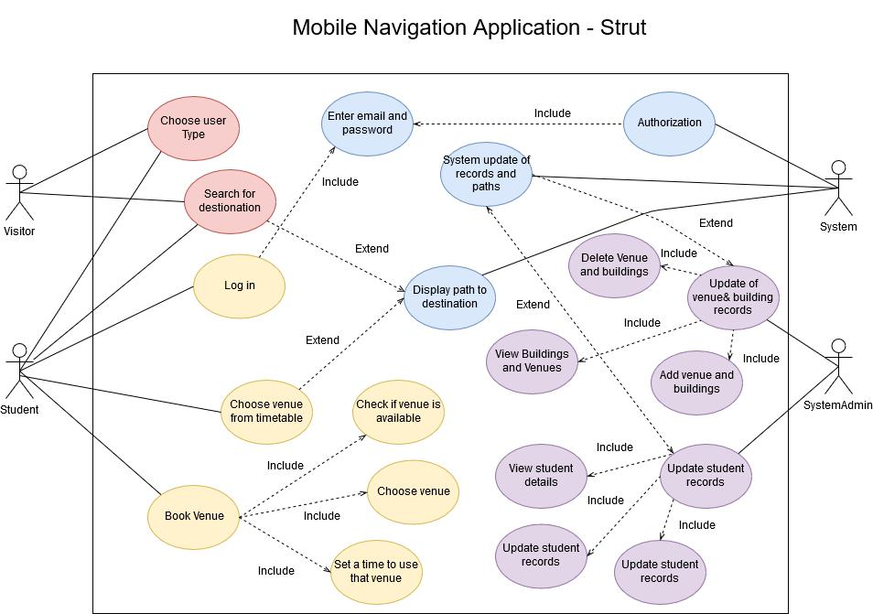
Minutes of the Meeting – 23 September 2019

Time: 11:00

Present

- Tashreeq

- Ismaeel

- Areeb

- Dean

- Khuliso

Absent

- Dahraan

- Jamie

Agenda:

1. Discuss Scenarios of Mobile Navigation

2. Plan to conduct interviews and send out questionnaires

3. Role assigned for Assignment 1

Minutes of the Meeting – 26 September 2019

Time: 9:45

Present

- Tashreeq

- Jamie

- Areeb

- Dean

- Khuliso

- Ismaeel -Dahraan

Absent

- None

Agenda:

1. How far everyone has gotten with their assigned sections

2. The basic structure of the mobile application.

3. What framework and programming languages will this application be created with.
Section E

Requirements

Functional Requirements

- Once a student logs in their usage is tracked in order to provide future suggestions for recurring venues at a specific period on a specific day

- Note: A non-student user does not require logging in

- Once the user enters their current location:

  - Either through typing in their location or, o Grabbing their GPS location

o Provide a path imprinted on the map to their destination

- Provide path through choosing period from timetable

- Provide venue booking facility

Data Requirements

- Student’s login contains

  - {Student Number, Password}

- Users’ getting a path contains

  - {GPS coordinates} – {Current location, Building, Venue}

- Student’s timetable contains

  - {Venue, Day, Module, Period}

- Student booking venues

  - {Venue, Day, Module, Period}

Environmental Requirements:

Profile 1: Willem Steenkamp

- Physical: Willem has a busy schedule during his days on campus. He has many classes to attend and as such, is constantly moving locations to get to the venues for his classes and society workshops. The UWC campus is large and venues are mostly scattered throughout the campus. There are always many people around campus walking to their different venues in a rush and the building locator signs on campus are few and not very detailed.

- Social: Willem often arrives late to his classes and workshops due to the number of other classes and/or workshops he attends throughout the day. Since classes are scattered

throughout campus and the time-period between classes is short, 10 minutes, he needs to be able to access the navigator app quickly with a clear interface and path to his next venue.

- Organizational: Willem will be able to access the app for directional and venue-scheduling help at any time as long as he has a stable internet connection on his phone while he is on campus. Accessing the app off-campus doesn’t help very much as its main purpose is on-campus navigation.

- Technical: The app will be a mobile app. Willem is familiar with the use of a mobile phone.

He is also familiar with the uses of mobile apps, and therefore won’t find any problems using the Strut mobile app. He may not be able to access the full use of the navigator app if his mobile phone does not have a stable internet connection, as the app makes use of an internet connection for navigation.

Profile 2: Thembile Mafu

- Physical: As a visitor of the University of the Western Cape, Thembile finds himself facing the task of having to park at the Life Science building and find his way to the Community

Health Sciences building. There isn’t a lot of parking space at the Life Science building. The direction and view of the Community Health Sciences building isn’t within sight from the

Life Science building. These locations are, however, not far apart and accessing parking at the Life Science building is very easy from the campus entrance near the Chemical Sciences building. It is not easy to find from the campus entrance near the Rugby Stadium as these locations are far apart and there are many roads on campus between these locations.

- Social: Thembile happens to only have five minutes to find the meeting venue from the time he gets to campus and he gets lost easily. Thembile would love to be able to easily navigate the university campus and reduce unnecessary stress before important meetings. He needs he needs to be able to access the navigator app quickly with a clear interface and path to the Community Health Sciences building quickly and easily.

- Organizational: Thembile will be able to access the app for directional help at any time as long as he has a stable internet connection on his phone while he is on campus. There are also security guards at the Life Sciences parking to aid in his direction. Accessing the app off-campus doesn’t help very much as its main purpose is on-campus navigation.

- Technical: The app will be a mobile app. Thembile is familiar with the use of a mobile phone. He is also familiar with the uses of mobile apps, and therefore won’t find any problems using the Strut mobile app. He may not be able to access the full use of the navigator app if his mobile phone does not have a stable internet connection, as the app makes use of an internet connection for navigation.

User Requirements

User Profile 1:

- System providing on campus navigation o Building-to-Building

o Venue-to-Venue

o Building-to-Venue (and vice versa)

- No learning burden on user

- Functionality should reduce frustration and anxiety associated with navigation (Especially when lost)

- Quick timetable access and path generation

- Path generation based on different use-cases

- Provide current venue as location or, o Read location from GPS then

o Set destination
  - Either from text entered or,

  - Read from timetable period selection

User profile 2:

- System providing on campus path navigation o Current location-to-Building

o Building-to-Building o Venue-to-Venue

o Building-to-Venue (and vice versa)

- No learning burden on user

- Quick access to search bar to search for destination

- No learning burdens.

Usability Requirements:

- Willem: is a fit individual that is a busy individual that is usually in a busy environment. He needs to be doing many different things during the day at specific times. He loves having a sense of accomplishment.

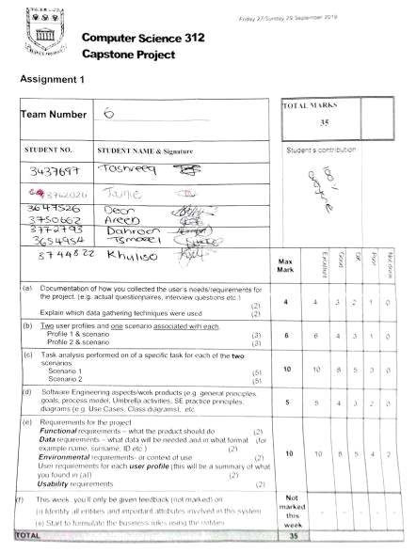
- Thembile: Has a wife and 2 kids and is constantly traveling. His time is precious, and he is a very busy person. He also loves the bold design of the BMW M5 and is an agricultural engineer who values the good use of efficiency.

